

BAHRIA UNIVERSITY, (Karachi Campus)
Department of Software Engineering
PROPOSAL
Course Title: Course Code:
Course Instructor: Class: BSE- (A)
Lab Instructor: Engr. Asma Shaheen Name: ______________________

PROJECT TITLE:
Telecommunication Network System

GROUP MEMBERS LIST:
Fahad Gillani 02-131222-083
Hira Raheel 02-131222-003

Submission Date: _29/11/2024 _
Contents
1. PROJECT ABSTRACT : 3
2. INTRODUCTION: 3
3. PROJECT SCOPE: 3
4. PROJECT FUNCTIONALITIES: 3
5. WORK FLOW DIAGRAM 4
6. NETWORK DIAGRAM 5
7. MODULE DISTRIBUTION: 6
8. REFERENCE: 7

PROJECT ABSTRACT :
The proposed network design for Tokyo NetConnect aims to establish a secure, scalable, and efficient communication system within the organization. The project leverages Cisco devices to build a network that adheres to the principles. By implementing robust network segmentation and security measures, the project ensures safe and seamless interaction among the company’s departments, on-premise systems, and cloud resources. This solution will empower Tokyo NetConnect to maintain business continuity while meeting its operational and security requirements.

INTRODUCTION:
The rapid growth of Tokyo NetConnect, a telecommunication company in Japan, requires a secure, scalable, and reliable network system to support the increasing demand for its IT services. Located in Tokyo’s iconic Shibuya district, Tokyo NetConnect operates multiple departments across two floors of Sakura Plaza. The network system must safeguard the confidentiality, integrity, and availability of data while enabling seamless communication, secure access to cloud resources, and efficient IT operations. This project focuses on designing and implementing a secure network infrastructure for the company, incorporating industry standards and best practices to meet the organization’s unique requirements.

PROJECT SCOPE:
This project involves designing and implementing a secure network infrastructure tailored to Tokyo NetConnect’s organizational structure and IT needs. The scope includes:
- Segmentation of LAN, WLAN, and VoIP users into separate network zones.
- Configuration of security policies on the Cisco ASA Firewall for traffic inspection and access control.
- Integration of the DNS and DHCP services.
- Setup of Cisco devices, including switches, voice gateways, WLC and routers.
- Provision of secure connectivity to Microsoft Azure resources for developers and cloud engineers.
- Ensuring scalability for future growth, reliability for uninterrupted operations, and robust security to protect sensitive data.

PROJECT FUNCTIONALITIES:
- Network Segmentation:
  - Separate VLANs for HR/Finance, Product/Marketing, Admin/Corporate, IT Support, Software Engineering, and Cloud Engineering departments.
  - Segregation of LAN and VoIP traffic.
- Security and Traffic Management:
  - Configuration of Cisco ASA Firewall to enforce security zones and inspection policies.
  - Implementation of role-based access control using Active Directory.
- VoIP Services:
  - Deployment of Cisco Voice Gateways for telephony.
- WLAN Management:
  - Centralized wireless management via Cisco WLC.
- Cloud Connectivity:
  - Secure access to Azure resources, including VMs and storage.
- Network Reliability and Scalability:
  - Use of redundant links and devices for failover.
  - Scalable architecture to accommodate growth.

WORK FLOW DIAGRAM
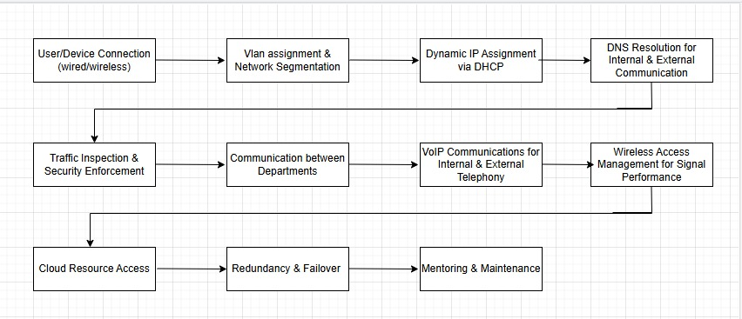

NETWORK DIAGRAM

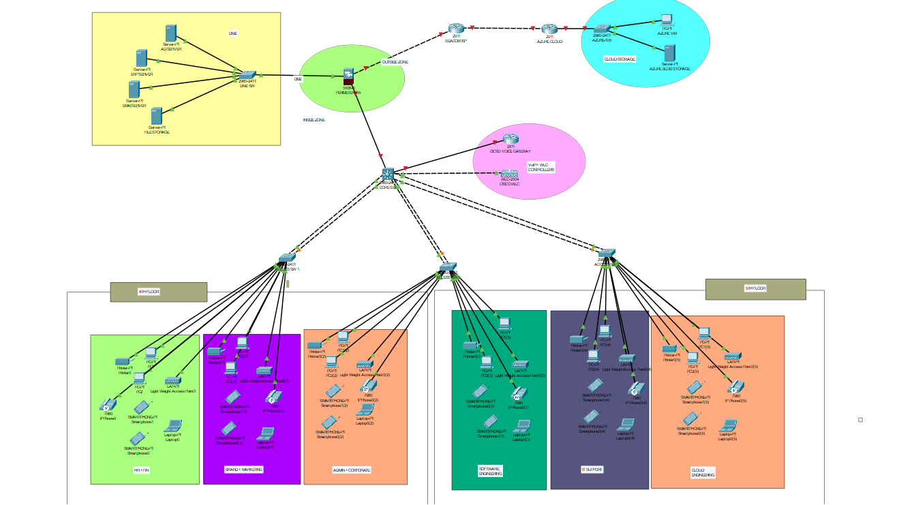

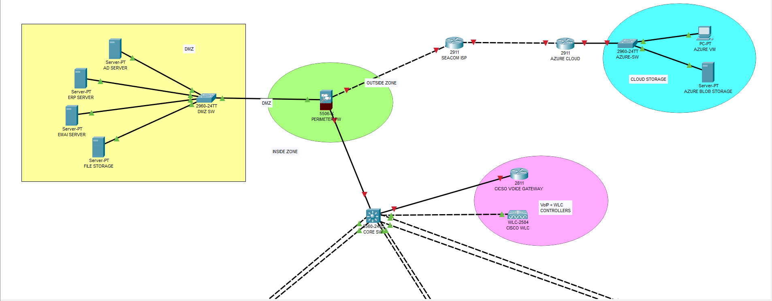
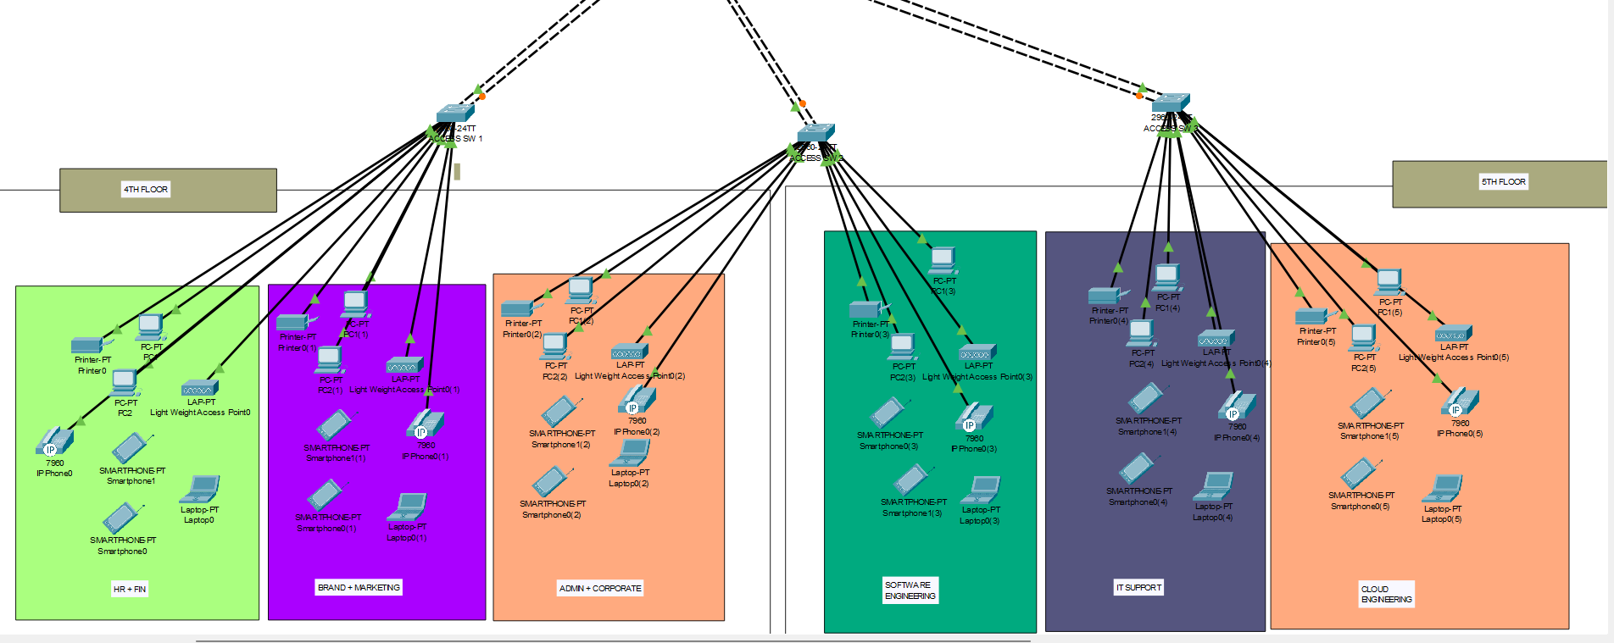

MODULE DISTRIBUTION:
The project is divided into the following modules:
- Network Design:
  - Planning and creating network topology.
  - Configuring VLANs and IP addressing schemes.
- Security Configuration:
  - Setting up firewall zones and traffic policies.
- VoIP and WLAN Implementation:
  - Configuring Cisco Voice Gateways
  - Deploying WLC for wireless connectivity.
- Cloud Integration:
  - Establishing secure connections to Azure resources.
  - Ensuring seamless access for developers and cloud engineers.
- Testing and Validation:
  - Testing network functionality, security, and performance.
  - Addressing vulnerabilities and optimizing configurations.

REFERENCE:
- Cisco Systems: https://www.cisco.com
- Best Practices for Network Security: https://www.nist.gov/

Teacher Signature: ______________________________________________
Remarks: ______________________________________________
Submission Date: ______________________________________________

